Automated Balloon Inspection Device

Final Proposal Report

Anthony Peters
Kevin White
Shane Pooler
Ryan Stevenson

2017 - 2018



Project Sponsor: POBA Medical
Faculty Advisor: Dr. Trevas
Sponsor Mentor: Bryce Igo

DISCLAIMER
This report was prepared by students as part of a university course requirement. While considerable effort has been put into the project, it is not the work of licensed engineers and has not undergone the extensive verification that is common in the profession. The information, data, conclusions, and content of this report should not be relied on or utilized without thorough, independent testing and verification. University faculty members may have been associated with this project as advisors, sponsors, or course instructors, but as such they are not responsible for the accuracy of results or conclusions.

Contents
DISCLAIMER.. 1
TABLE OF CONTENTS. 2,3
1 BACKGROUND.. 4
1.1 Introduction. 4
1.2 Project Description 4
1.3 Original System
2 REQUIREMENTS. 4
2.1 Customer Requirements (CRs) 4
2.1.1 Balloon range 0mm to 325mm in length and 1.25mm to 45mm in diameter 5
2.1.2 Measure all balloon dimensions 5
2.1.3 Measure size and distance of visual defects 5
2.1.4 Inspection under polarized lighting 5
2.1.5 Rotational and Longitudinal movement for inspection 5
2.1.6 Inflation for inspection 5
2.1.7 Equipment must be able to fit on a table 5
2.2 Engineering Requirements (ERs) 6
2.3 Testing Procedures
2.4 House of Quality (HoQ) 6
3 EXISTING DESIGNS. 6
3.1 Design Research. 6
3.2 System Level 7
3.2.1 Existing Design #1: Autoi-360. 7
3.2.2 Existing Design #2: BalloonSpect. 8
3.2.3 Existing Design #3: LumetriScan. 9
3.3 Functional Decomposition. 10
3.3.1 Black Box Model 10
3.3.2 Functional Model. 10
3.4 Subsystem Level 11
3.4.1 Subsystem #1:Rotational Movement. 11
3.4.1.1 Existing Design #1: RT-2 Motorized Rotary Positioner 11
3.4.1.2 Existing Design #2: Gears 12
3.4.1.3 Existing Design #3: Pneumatic Rotary Actuator 12
3.4.2 Subsystem #2:Linear Motion. 13
3.4.2.1 Existing Design #1: Modular Automation System 13
3.4.2.2 Existing Design #2: Robot Linear Motion LM30DC07AS 13
3.4.2.3 Existing Design #3: Piston Linear Actuator 14
3.4.3 Subsystem #3: Prototype Camera 14
3.4.3.1 Existing Design #1: Panasonic ZS100 Lumix 4K 20MP Digital Camera 15
3.4.3.2 Existing Design #2: Nikon D7100 15
3.4.3.3 Existing Design #3: Fujifilm X-T2- Mirrorless Digital Camera 16
4 DESIGNS CONSIDERED.. 16
4.1 Design #1: Rotational and longitudinal stage 16
4.2 Design #2: Moving camera 17
4.3 Design #3: Inboard camera design 18
4.4 Design #4: Overhead camera design 18
4.5 Design #5 Microscope design 18
4.6 Design #6: Scanner 19
5 Design Selected
5.1 Rationale for Selected Design
5.2 Design Description
6 Proposed Design
7 REFERENCES. 20
8 APPENDICES. 21
11.1 Appendix A: Design considerations 21
11.2 Appendix B: Descriptive Title. 22,23

1 BACKGROUND
1.1 Introduction
For this project the team was tasked by POBA medical in developing an automated visual balloon inspection equipment. POBA medical currently uses a manual visual balloon inspection equipment thus need a automated to device to inspect their catheter balloons more efficiently. The device will be developed to help inspect many different types of catheter balloons in a more efficient and accurate process. This equipment will be significant to POBA in that it will help measure the dimensions and detect any defects along the entire length of the balloon. Determining the balloon’s quality features is essential before introducing the product for medical needs. The development of this inspection device will be very useful for the overall inspection process for POBA’s manufactured catheter balloons.
1.2 Project Description
POBA medical currently uses a manual visual balloon inspection equipment to determine the quality of their manufactured catheter balloons. Developing an automated visual balloon inspection device will increase the rate of inspected balloons as well as improve the performance of the overall inspection.
The following is the original project description provided by POBA medical:
Design automated visual balloon inspection equipment.
- Equipment should be able to measure all balloon sizes ranging from 1.25mm to 45mm in diameter. Balloon lengths ranging from 0mm to 325mm minimum.
- Measure all outer balloon dimensions. (Proximal and distal neck OD, cone length and angle, working length diameter and length)
- Measure size of visual defects (“gel spots”, ”Fish eyes”, ”Crows Feet”, etc. )
- Measure distance between visual defects and number of defects within a specified area.
- Inspection under polarized lighting
- Rotation for inspection
- Longitudinal movement for inspection
- Inflation for inspection (Equipment must be able to withstand 40 ATM of internal pressure)
- Equipment will be able to sit on a table

2 REQUIREMENTS
2.1 Customer Requirements (CRs)
Each of the following requirements have a weighting associated with them detailing their importance to the final project. The CR’s are given directly in the project description presented by POBA Medical as detailed above. The number next to the caption will be its weighted total. The weighted range is from 0-10
2.1.1 Balloon range 0mm to 325mm in length and 1.25mm to 45mm in diameter (9)
These numbers are the industry standard for balloon inspection devices. Therefore, it is only natural that we are expected to meet the level of performance and design of the products on the market right now. Our inspiration model, Auto-i 360, is only able to measure balloons up to 300mm so we will be exceeding that by another 25mm. This CR has a level of importance of 9 because of our clients need to inspect all sizes of balloons that they manufacture..
2.1.4 Inspection under polarized lighting (5)
Polarized lighting is not something that one can find on any given automated balloon inspection device, therefore this is a unique requirement given to us. The polarized lighting allows the camera to see any defects better than under regular lighting. This is a task that will not be too difficult to implement therefore it scores a 5.
2.1.5 Rotational and Longitudinal movement for inspection (10)
This CR scored the highest because without it the camera has no way of taking pictures of the entire balloon. This makes this CR the most important. Our project must be able to move linearly and rotate the balloon to be able to capture a full profile of the balloon.
2.1.6 Inflation for inspection (7)
This is a fairly important CR which is why it comes in at an importance level of 7. During their use, catheter balloons are filled with air to allow a surgeon to open an artery. Therefore, finding a way to fill the balloon with air during the inspection will allow us to see that it can hold the required pressure used in the industry.
2.1.7 Equipment must be able to fit on a table (4)
This CR scored low because of our ability to make our design the entire size of a table. Early thought were that it had to be small and maneuverable but once we spoke to our client we gained more info that it can be as small as we want it to be or as large as the table itself. This gives us a lot of freedom with our designing.
2.2 Engineering Requirements (ERs)
The ER’s were created based off of the CR’s. The difference between the two is that ER’s have quantifiable numbers that are determined by the engineer. This gives us a guide to follow while we are designing.

Table 1 - Engineering Requirement Values
Requirement | Units | Target | Tolerance | Range
Diameter of balloon | mm | N/A | 0 | 5-45
Length of balloon | mm | N/A | 0 | 5-325
Polarized Lighting | λ | Undetermined | Undetermined | n/a
Rotational movement | ° | 360 | ± 1 | 359-361
Longitudinal movement | mm | 162.5 | ± 5 | 157.5-167.5
Inflation of balloon | psi | 300max | ± 10 | 0-300
size | ft | 3.5 | ± .5 | 3-4 feet long  1.5 foot depth

2.3 Testing Procedures
To test the system we will be corroborating with POBA’s software designer to implement some functionality. He will be teaching us how to code the movements and have all the information sent to one program for it to be analyzed. After a program is installed, we will run air through the system to make sure that the air system functions properly. Once all preliminary tests are concluded, we can install the catheter balloon and run the program and have the camera take the pictures while the balloon is rotating.
2.4 House of Quality (HoQ)
The house of quality is used to highlight the CR’s and their relationship with the ER’s. Also included in the HoQ are the target and tolerance values. See appendix A for HoQ.

3 EXISTING DESIGNS
This section will explore what devices were found by the team during the preliminary research phase of the project. There is a minimal amount of balloon inspection devices on the market that can inspect a catheter balloon in full detail. To fully understand what this project would entail, different types of balloon inspection devices were researched and analyzed. Each existing design is broken down into smaller sub systems throughout this section to explore the functionality, and notable features of each device.
3.1 Design Research
The beginning of our research was jumpstarted by POBA Medical . They gave us the name of the current state of the art machine, which is the Auto-i 360, similarly known as Automated Balloon Visual Inspection System manufactured by Interface Catheter Solutions. POBA offered a packet for us to take home with details about the Auto-i 360. Using the Auto-i 360 as a benchmark, the team began researching and gathering information regarding similar balloon inspection devices.To optimize the redesigned catheter balloon inspection device, key aspects and features were considered from the three different devices that are currently on the market.
3.2 System Level
Catheter balloon inspecting devices have a variety of features. Most common of all is the automated functionality. Gears and other rotary devices will be used to properly position the catheter balloon such that a camera will be able to capture images of any defects. Software would then use these images and data to determine which defects a balloon has and whether it can be used. This section explores notable features from existing designs, which will allow the team to get ideas for the prototyping phase of this project.
3.2.1 Existing Design #1: Auto-i 360
Since 1995, Interface Catheter Solutions has been heavily involved with balloon and catheter manufacturing. This company has created over 2,100 balloon designs along with a wide range of balloon catheter production and testing equipment. The Auto-i 360 was created by Interface Catheter Solutions in order to reduce the inspector-to-inspector balloon inspection variability. Before this technology, inspectors would miss defects and disagree on defect classifications. However the Auto-i 360 device is capable of tabulating balloon defects and and reproducing data that is 90% repeatable.
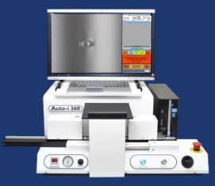
Figure 1: Auto-i 360
Notable Features
- Quick, easy setup with fast cycle times (approximately 30 seconds for standard balloons).
- Automatically rotates & inspects.
- Rotary air chucks made inspection process faster than standard.
- Immediate detailed visual & data reports.
- Classifies defect type and size with pass/fail analysis.
- Software filters significantly reduce false positives.
- Pneumatic rotary air chucks for quick and easy balloon loading/unloading.
- Enhanced pressure gauge for pressure accuracy and reliability.
- High-pressure capability up to 13 atmospheres.
- Compatible w/ compressed air/nitrogen.
- Integrated ionizing knife to reduce balloon particle interference.

3.2.2 Existing Design #2: BalloonSpect
STPL, located in Gujarat, India , is a company that specializes in manufacturing & exporting laser technology and vision based capital equipments. This company manufactures and produces medical products that range from fully automated laser cutting machines, to fully automated vision inspection systems for inspecting stents and catheter balloons. The BalloonSpect is a fully automatic balloon geometry inspection system. This device is capable of measuring diameters, along with cone angle and wall thickness of balloons. Software within the device also allows for detailed color coded graphical presentation of balloon measurements.

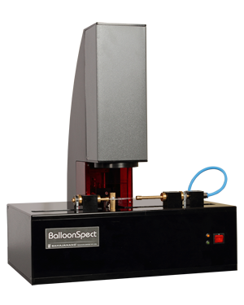
Figure 2: BalloonSpect

Notable Features
- Fully automatic non contact, accurate and repeatable balloon geometry inspection system.
- Measures diameter, cone angle and wall thickness of balloon.
- Color coded graphical presentation of profile diameter measurement.
- Refine manufacturing or QC process through graphical SPC analytical report.
- Measures balloon up to 60 mm length (other options available).
- Measures balloon up to 15 mm diameter (other options available).
- Profile measurement accuracy: Better than 6 micron.
- Wall thickness measurement range: 0.5 to 70 micron (Single side).
- Wall thickness measurement accuracy: Greater of 0.5% or 0.05 micron.

3.2.3 Existing Design #3: LumetriScan
Lumetrics has be developing and manufacturing high-precision thickness measurement and gauging systems since 2002. Their clientele include Fortune 500 companies in the medical field, pharmaceutical, food packaging, eye-care products and coatings industries. Lumetrics manufactures non-contact thickness measurement and optical inspection systems for medical, glass, food packaging, ophthalmic, automotive, and film industries.

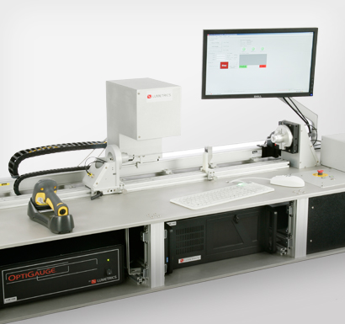
Figure 3: LumetriScan 360

Notable Features
- Utilizes the OptiGauge® precision thickness measurement system.
- Inspect tubes, mandrels, and medical balloons.
- Balloons can even be inflated to a precise test pressure during inspection.
- System works at-line or off-line.
- Traversing probe (moving camera).
- Rotational stage with removable collet .
3.3 Functional Decomposition
3.3.1 Black Box Model
Creating a Black Box Model simplifies a machine. The machine we are designing is not complex, but the black box helps us to determine what our final design must be able to do.
Measure and Analyze Balloon
Catheter balloon
Electricity
Start signal
Noise
Measurements
Pictures
Figure 4 : Black Box Model
Creating this model reminds the team that we are not making a fully functional balloon inspection machine. Our job is to essentially create an exoskeleton of the full product. We are not tasked with creating the code for the machine. This means our machine should be able to just take pictures of the balloon and have it upload to the computer..
3.3.2 Functional Model
Creating a functional model goes more in depth about how the different parts of the machine interact with each other. The black box model is smart to create before making a functional model because you can see the inputs and outputs of the system. Establishing this helps guide the flow of your functional model. It is easier to create something when you know what you want your output to be. Creating a functional model shows how the different parts of the system are connected. This will help when we have all of our manufactured pieces and are trying to make the system work in totality.
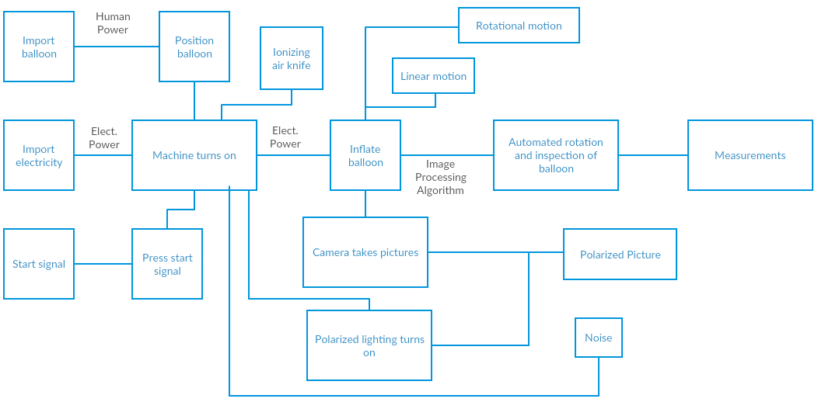
Figure 5: Functional Model

3.4 Subsystem Level
3.4.1 Subsystem #1: Rotational movement
Rotational movement is an important subsystem for the device. The catheter balloons need to be rotated 360 degrees in order for sufficient inspection of the entire balloon. The rotational subsystem also needs to be programmable in order for the user to inspect desired section of the balloon.
3.4.1.1 Existing Design #1: RT-2 Motorized Rotary Positioner
The RT-2 is an efficient rotary positioner manufactured by newmark systems. It is capable of a max speed of 30 degrees per second and a maximum payload weight of 10 lbs. The RT-2 rotary stage is a well built and low profile being only 39mm in thickness. It can also be programmed for precise commands utilizing an arduino board.
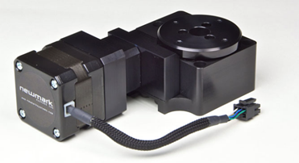
Figure 6 : RT-2 Rotary Positioner [1]
3.4.1.2 Existing Design #2: Gears
Gears are necessary parts to create rotation within the system. As seen in the figure below the pinion gear moves along the rack gear to create full 360 degree rotation of the system. Gears can be programmed to move at desired speeds and will be a fundamental part of the rotary subsystem.
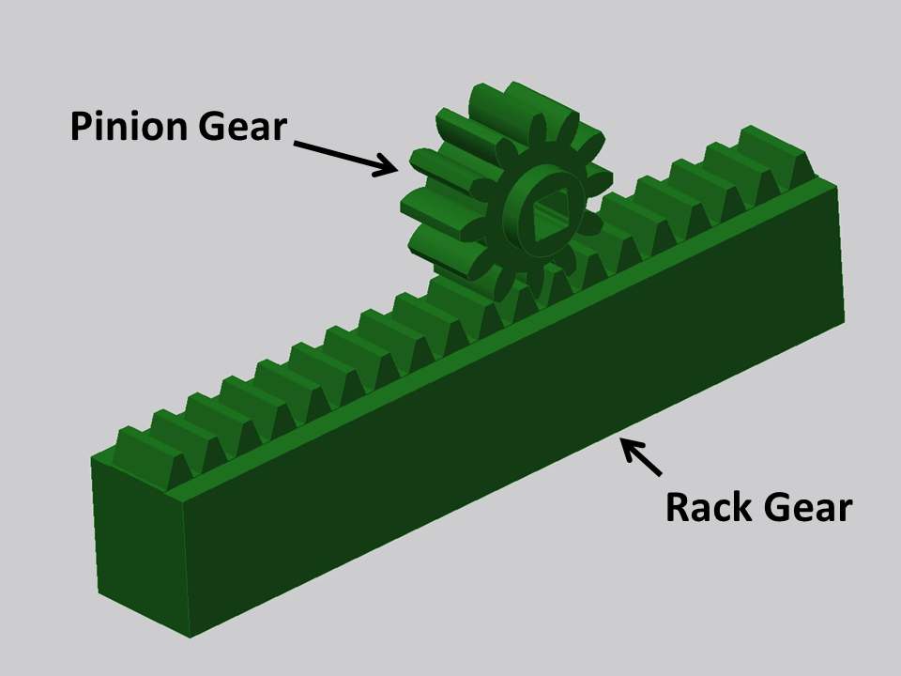
Figure 7: Pinion and Rack Gear [2]
3.4.1.3 Existing Design #3: Pneumatic Rotary Actuator
PV rotary vane actuators are available in four sizes and the torque ranges 0.69 to 30.96Nm at 6 bar. There are two versions that produce twice the torque output with similar dimensions. These versions are the 280° single vane and a 100° double vane.
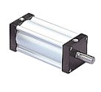
Figure 8: Pneumatic Rotary Actuator [3]

3.4.2 Subsystem #2: Linear Motion
Installing linear movement into the device is vital for two reasons. For one, linear motion allows the machine to calculate the length of the balloon. Lateral motion also helps the camera mounted onto our system to take very close up and detailed pictures of the surface of the balloon. Without linear movement, the camera would have to be farther away to take a picture of the full balloon together. Resulting in low quality pictures and the possibility that the computer will not catch defects.
3.4.2.1 Existing Design #1: Modular Automation System
This modular system made by Robotunits can be specially designed for customers. The system is easy to assemble and quick to integrate into your system. A downfall is that the system by itself does not have a way to move back and forth. An external motor would have to be attached to this system to create the linear motion.
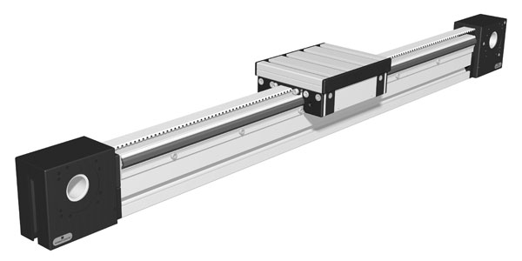
Figure 9: Modular Automation system [4]

3.4.2.2 Existing Design #2: Robot Linear Motion LM30DC07AS
What is appealing about this design is the attachment already on the tracks. Some of our designs have the camera sitting above the balloon. The blue attachment makes it easy to devise an attachment where a camera could sit on pointing down. This means this setup serves more than just one purpose. Cutting down costs and the need to make more parts. With a bass stroke of 5400 mm and max load of 500 kg, this linear motion robot has the strength and length to meet our customer requirements.
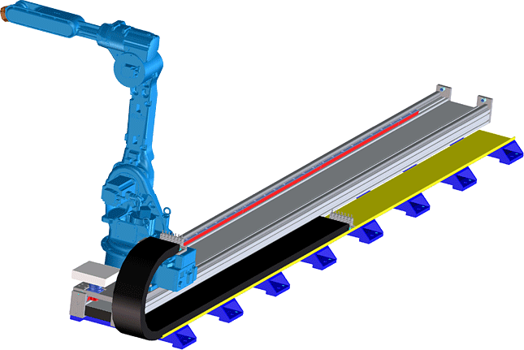
Figure 10: Robot Linear Motion LM30DC07AS [5]
3.4.2.3 Existing Design #3: Piston Linear Actuator
The piston actuator is controlled by the input of air on either side of the piston and seals. In our application, to slowly take picture longitudinally, the machine would be programmed to push air through extend flow port. Causing the piston rod to extend out. This function is vital to measuring and taking pictures of the entire inflated balloon. A positive with using this setup is that the internal structure of the piston is not affected by external conditions. Water on the outside surface or shock won’t affect the motion of the piston.
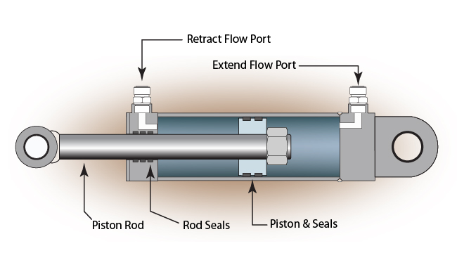
Figure 11: Piston Linear Actuator [6]

3.4.3 Subsystem #3: Prototype Camera
One of the most important pieces of the machine, if not the most important, is the camera used. The camera must be of high quality and be able to take pictures of small objects. Taking pictures of large objects is not important because that is not what the camera will be used for. The only objects this camera will be taking pictures of are tiny defects on the surface of catheter balloons. The camera used must also be digital so it can show pictures and give the computer something to analyze.
3.4.3.1 Existing Design #1: Panasonic ZS100 Lumix 4K 20MP Digital Camera
This camera is small and very high resolution. It also has the capability of doing video if we so choose to take videos of the balloons instead of pictures. The wifi capability gives us an option of installing an app on the computer used on the machine as possible way of sending pictures to our computer.
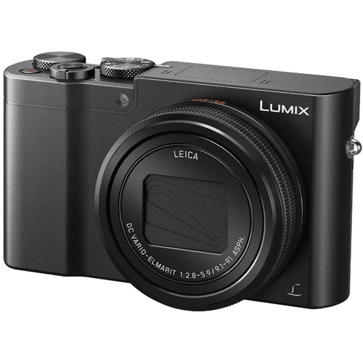
Figure 12: Panasonic ZS100 Lumix 4K 20MP Digital Camera
3.4.3.2 Existing Design #2: Nikon D7100
While this camera is a couple hundred dollars more in price, it comes with more benefits. A big positive with this camera is its ability to accommodate different lenses. This ability brings comfort because if the given lense is not the best for what we want, we can always order a better lense after further research. The camera also has a time lapse function. Making it easier to control how fast we want pictures of the balloon taken. This also means we don’t have to create program for the camera to take pictures.
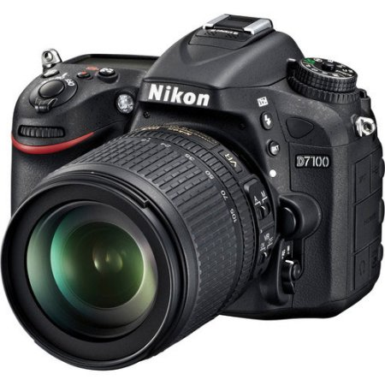
Figure 13: Nikon D7100
3.4.3.3 Existing Design #3: Fujifilm X-T20 Mirrorless Digital Camera
The most expensive one of the three existing designs chosen is this camera. It’s extra cost comes with features not seen in the previous two. One feature that grabbed attention is the camera’s quality of doing above head and close to ground shooting. Some designs have the camera pointing down and very close to the balloon so this capability will be helpful. The autofocus feature expanded from the previous version to 325 points. With more points the camera can use to autofocus means the more focused it will be on the defects and edges of the balloon.
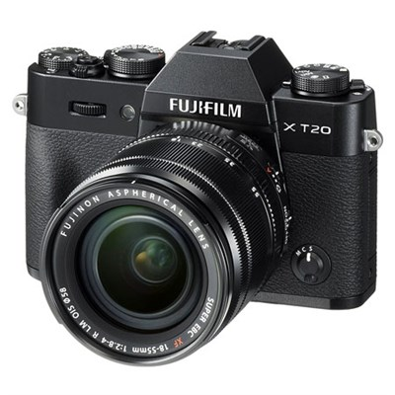
Figure 14: Fujifilm X-T20 Mirrorless Digital Camera
4 DESIGNS CONSIDERED
4.1 Design #1: Rotational and Longitudinal stage
This design below incorporates rotational and longitudinal movement on one stage. The camera is stationary and analyzes the balloon as it moves across and rotates. A collet is connected to a mandrel which holds the balloon. The rotary unit has the ability to rotate the specimen 360 degrees for inspection. The pros for this design are that the camera is stationary creating more accurate inspection results. The cons for this design are that it may take up a lot of space and movement of the balloon can cause bad readings.
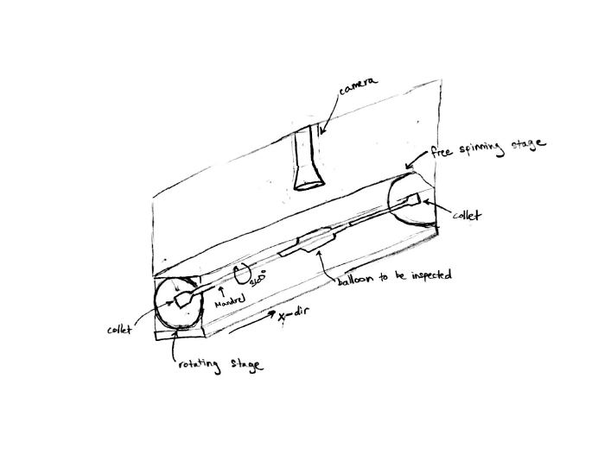
Figure 15: Design #1
4.2 Design #2: Moving camera
The design below utilizes a longitudinal moving camera for inspection along the entire length of the balloon. The balloon does not move in the x-direction but only rotates. The pro for this is that the balloon is more steady in that it only rotates. The con for this device is that the camera is moving a lot which can cause errors during inspection due to the camera not being focused.
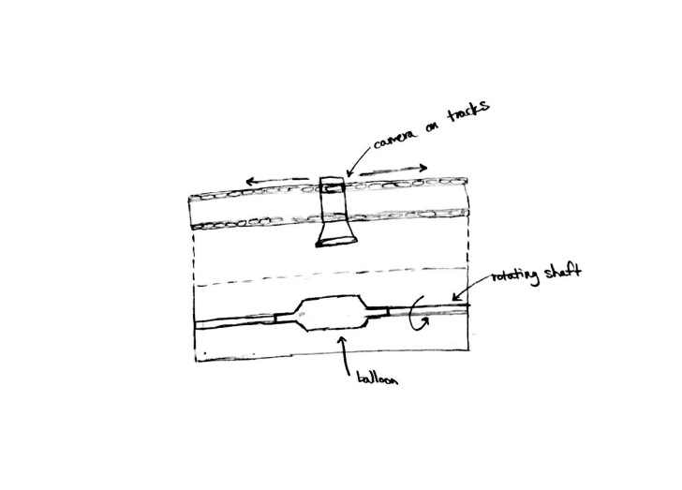
Figure 16: Design #2
4.3 Design #3: Inboard camera design
The design below features an inboard camera that is taking pictures within an enclosure that encompases the catheter balloon. A good thing about this design is that it allows the polarized lighting to be uninterrupted. A con for the device is that the enclosure make installation of the balloon more difficult.
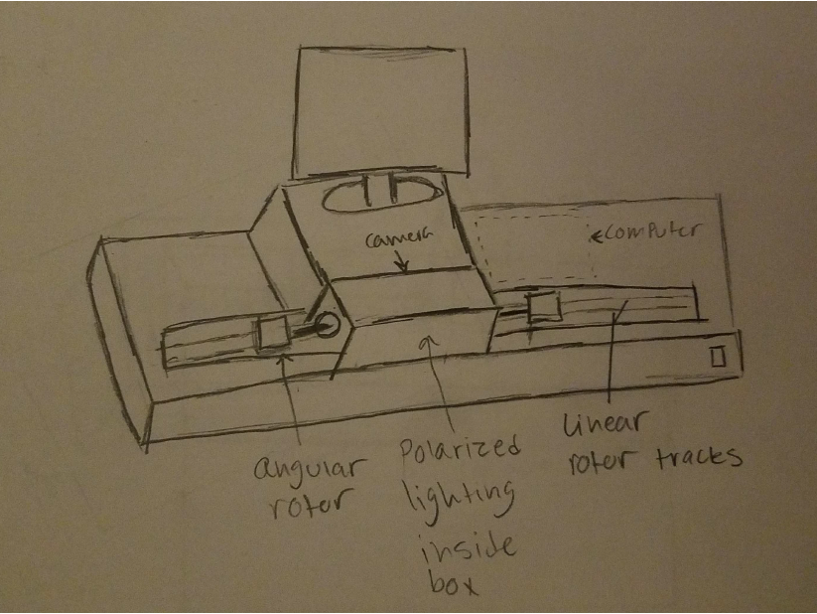
Figure 17: Design #3
4.4 Design #4: Overhead camera design
This design here features an overhead camera and an inboard computer flush with the frame. This design is not all that practical due to the computer taking up more space and making the whole frame too large. Overall there would be too much empty space that we could utilize otherwise.
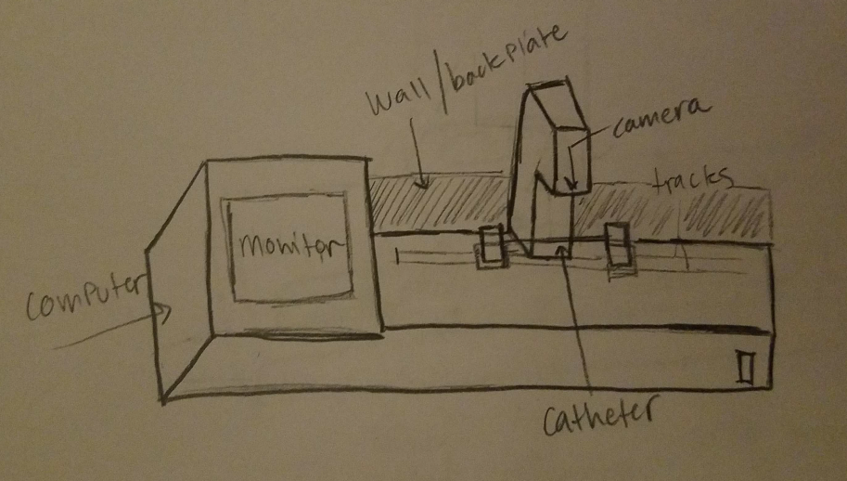
Figure 18: Design #4
4.5 Design #5: Microscope Design
This design houses a stationary camera over the catheter balloon. All angular and longitudinal motion is done on the arm that extends out of the body. The angular turning of the balloon would come from a spinning gear with a high strength band that rotated the small sub system. The longitudinal motion would come from a motor that would move the arm left to right.
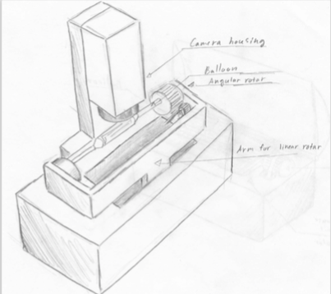
Figure 19: Design #5

4.6 Design #6: Scanner
This design is an attempt to shrink the size of the overall system. The balloon would rotate on a small set of gears that is driven by a belt. Beneath the balloon is where the high resolution camera would be house. Further research on high resolution scanning technology could provide an alternative to using a camera, and could potentially be more cost effective.
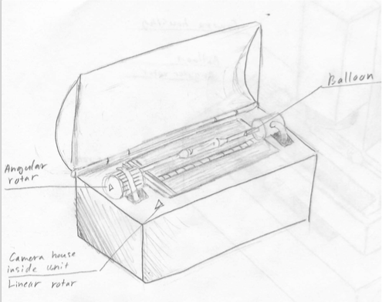
Figure 20: Design #6
5 DESIGN SELECTED
5.1 Rationale for Design Selected
The team came up with eight different types of automated visual balloon inspection devices. Each design contained a unique characteristic distinguishing all eight designs. To limit the amount of overall designs, a Pugh Chart (Table 2) was created. As seen below the overhead camera design was chosen as the datum idea and all other designs were compared to it. Each design either matched the criteria in a positive way meaning it satisfies that criteria or if it did not then it was given a negative sign. The four designs that were favored were the moving camera, stationary camera, scanner, and inboard camera designs. These design also were favored out of the eight by the team.
Table 2 - Pugh Chart
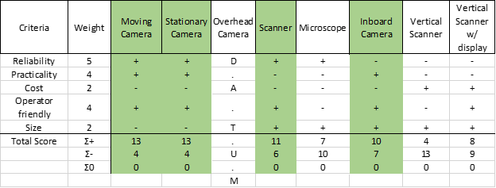
The four designs decided by the Pugh Chart and the team were then further analyzed by a Decision Matrix (Table 3). The Decision Matrix displays the weighted criteria as well as the total for each of the four designs. Each design is rated on a scale of one to five, one being poor and five being great. Each criteria is also weighted based on the importance for the overall final design.
Table 3 - Decision Matrix
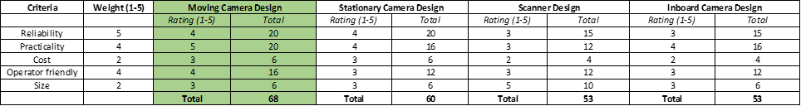
The selected final design for the automated visual balloon inspection device was the moving camera design. The moving camera design had the highest score for the decision matrix as well as being the favored design by the entire team. This design was favored in that it was easy to incorporate all moving sections of the design. This design was also favored by our client, POBA medical.
5.2 Design Description
5.2.1 Rotational Design Selected
The rotational design selected for the overall design was the RM-3 Rotary Stage [1] (Figure 21) manufactured by Newmark Systems. The RM-3 has a maximum speed of 30 degrees per second and has a maximum load capacity of 45 pounds. The main requirement the design satisfies is a travel range of 360 degrees so the entire outer diameter of the balloon can be inspected. Two RM-3 stages will be used for the final design in order to move both ends of the catheter balloon at exact speed and time.
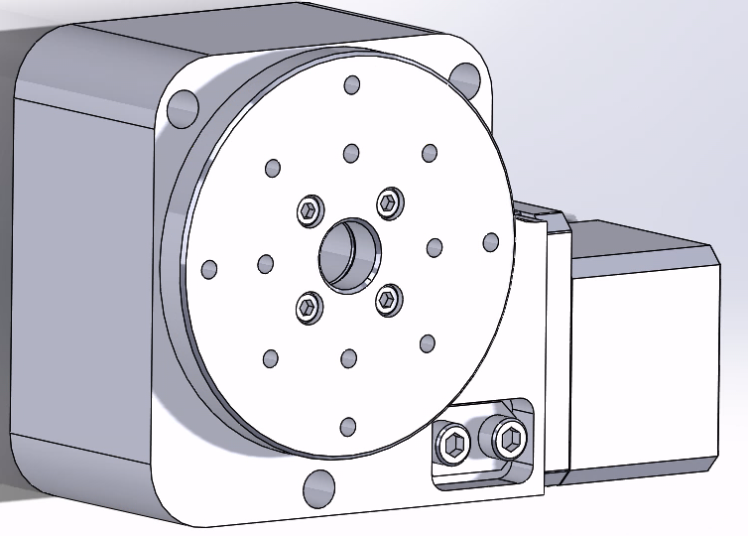
Figure 25: RM-3 Rotary Stage SolidWorks Model [1]
5.2.1.1 Rotational Attachments
Attachments for the rotary stage were needed in order for proper inspection of the catheter balloons. To inspect each catheter balloon, air must be inputted into the balloon prior to inspection. Using the Rotary Union (Figure 26) below from DSTI we can input air into the balloon while the balloon rotates. We can also input air into the bladder of the Tube Grabber (Figure 27) to grip the balloon using this rotary union. This rotary joint is made of anodized aluminum and is rated for a maximum air pressure of 600 psi which meets our customer's requirements. Figure 27 below displays the Tube Grabber CCB which will be used to hold each catheter balloon in place during inspection. It operates like an air chuck using a rubber seal to tightly grip the balloon. The Tube Grabber CCB is suitable for processes up to 300 psi and is suitable for all balloon diameters specified by POBA. It is made of anodized aluminum and features quick and safe operation.
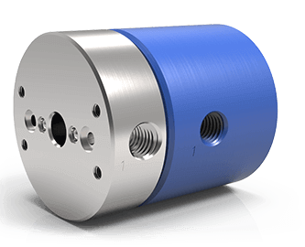
Figure 26: Rotary Union [13]
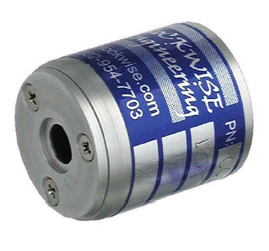
Figure 27: Tube Grabber CCB [14]

5.2.2 Linear Motion Design Selected
The linear travel stage selected was the D-Slide long travel linear stage (Figure 22) also manufactured by Newmark Systems. This linear stage utilizes a lead screw with a pitch of 10 mm powered by a stepper motor which can travel at up to 100 mm/sec with an accuracy of 0.0006 mm/mm. Our client (POBA Medical) wants us to be able to measure up to 325 mm in length balloons. Along with the length will be a minimum of 75 mm of excess plastic on each end of the balloon. Therefore we determined that we would use the 600 mm version of this linear stage. The maximum weight rating of the stage is 150 lbs. Which is more than enough to carry the weight of the camera and its housing without deflection.
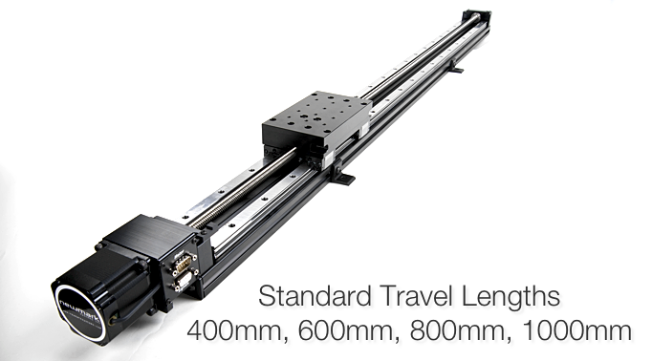
Figure 28: Linear Travel Stage with stepper motor

5.2.3 Camera Selected
Our design needed to incorporate a type of microscopy camera powerful enough to take pictures of defects that are too difficult to see with the naked eye. The camera needed to also be programmable and be able to progressively scan each catheter . We chose the Blackfly camera by Edmund Optics (Figure 28) because it meets our imaging requirements. The USB 3.0 Blackfly is a color camera that is specifically engineered for machine vision systems, and includes capture software. This camera is compact and lightweight which doesn't add much volume to the overall design.
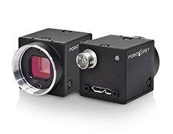
Figure 29: BFLY-U3-23S6C-C USB 3.0 Blackfly

The addition of the 0.16X TECHSPEC SilverTL™ Telecentric Lens (Figure 29) by Edmund Optics will allow us to take even more accurate images. This particular lens attachment was also engineered specifically for machine vision production applications that require accurate measurements. With this lens we are able to attach color filters, polarizers, protective windows, and illumination adapters for LED or fiber-optic ring lights. This lens will allow the user to magnify images up to 0.16 times to get more precise measurements.

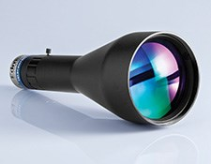
Figure 30: 0.16X TECHSPEC SilverTL™
5.2.4 Pressure Input Design Selected
As stated in the testing procedure, a mixture of Oxygen and Nitrogen will flow through the balloon while the camera takes pictures. The mixture of gases means that the compressor valve must be compatible with the gases it will be working with. The compressor valve also must be able to deliver 300 psi into the balloon and handle an inlet pressure of at least 1000 psi. The 1000 psi requirement comes from knowing that the output pressure of large tanks of pressurized nitrogen and oxygen are typically 1000 psi. Taking in all of these requirements, gives us the air compressor valve below. It has a max inlet pressure of 3000 psi which is much greater than what is required. The delivery pressure goes up to 500. Those two requirements were easy to meet. Finding a valve that is compatible with multiple gases was the difficult part. This valve is listed as being good with Argon, Helium, and Nitrogen. It is listed to work with only one of the gases it will be used with, we as a team think that its ability to handle those three gases means it will be able to have oxygen too.
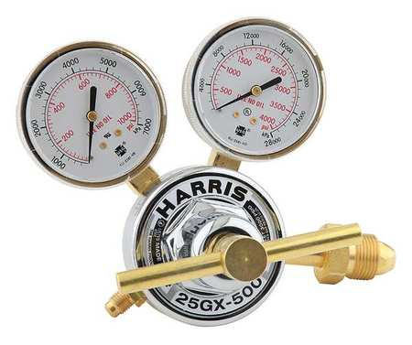
Figure 31: Pressure Regulator

5.2.6 Polarization Design Selected
This subsystem was created when the effects of polarization on pictures was found out. When taking pictures of materials that have a transparent property, polarization enhances the quality of the photos. When using the right polarization, it can also make that material very transparent and look non-existent in pictures. This quality is very desirable for our situation since the material we will be taking pictures of is see through. Polarizers come in two different forms though, regular and variable. The regular polarizer only spits out a small range of wavelengths. The variable polarizer can output a much wider range of wavelengths. The clear decision is to use a variable polarizer. The plan is to put one on the variable polarizer on the camera lense. Causing all of the pictures taken by the camera to be polarized. Unfortunately I do not have the specifications of the one we will be using. POBA has one selected already and they do not know the specifications themselves. Even though I do not know the wavelength and size of the polarizer, POBA likes it and says it is compatible with the camera we will be using so we know it works. It also means we will not need to worry about using our budget to buy one.
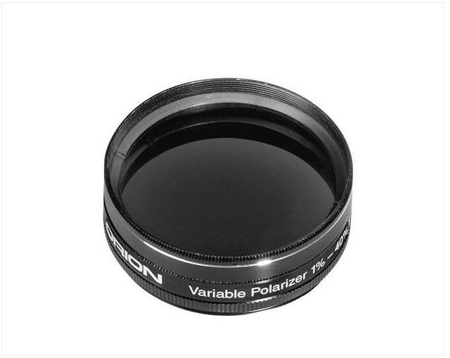
Figure 32: Polarized Lens

6 PROPOSED DESIGN
6.2.1 Final design
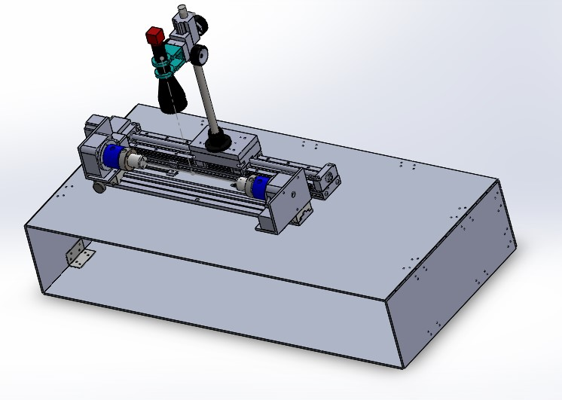
Figure 33: Final Design
This design is similar to that of the Lumetriscan 360 in Figure 3. It is a simple design in which the components are shown on the top of the model. The few things that are undetermined as of now are the air pressure system and the lighting. There is also still more tinkering to be done to our individual parts.. This design will be around 3.5 feet in length. It will also be quite heavy which is why we have selected Aluminum 3003 to be the material for the frame. This will allow the members at poba to be able to move the system with ease.
7 TESTING

8 CONCLUSIONS

9 REFERENCES
[1] Newmark Systems Inc. http://www.newmarksystems.com/
[2]http://curriculum.vexrobotics.com/curriculum/mechanical-power-transmission/power-transmission
[3] The Paker Appliance Co. http://ph.parker.com/us/en/pneumatic-rotary-actuators
[4] Robotunits http://www.robotunits.com.au/linear-motion-system/
[5] OPL Manipolazione http://www.oplmanipolazione.it/en/robot-linear-motion-1.php
[6] CPI https://www.cpi-nj.com/what-is-a-linear-actuator/
[7] Buydig https://www.buydig.com/shop/product.aspx?sku=PNDMCZS100K&ref=PLA&omid=103&utm_source=GooglePLA&utm_medium=CSE&utm_item=PNDMCZS100K&CAWELAID=230005120001239091&catargetid=230005120001271940&cadevice=c&gclid=Cj0KCQjw09zOBRCqARIsAH8XF1b5BmWEDF13m-JRpqotGIL1eGwSlna_CglxlIqE4xszym9kZipOTK4aAjwEEALw_wcB
[8] Walmart https://www.walmart.com/ip/fast-Track-D7100-W-18-105mm/23516807?wmlspartner=wlpa&selectedSellerId=6331&adid=22222222227017244598&wl0=&wl1=g&wl2=c&wl3=42973344872&wl4=pla-81465912032&wl5=9030289&wl6=&wl7=&wl8=&wl9=pla&wl10=115064590&wl11=online&wl12=23516807&wl13=&veh=sem
[9] Beach Camera https://www.beachcamera.com/shop/product.aspx?sku=FJXT20XF1855K&ref=PLA_Beach&omid=103&utm_source=PLA_Beach&utm_medium=CSE&utm_item=16542751&CAWELAID=230006090000158732&gclid=Cj0KCQjw09zOBRCqARIsAH8XF1Z6W53yJkbJwlF9BQr46PRYTuwKpPWrlRtlvd5SazFbmBY1Q4XQELMaAl_qEALw_wcB
[9] interface solutions. https://nitinol.com/2012/02/interface-catheter-solutions-auto-i-360-balloon-inspection-system-delivers-positive-gage-rr-results/
[10]lumetrics
http://www.lumetrics.com/capabilities-products/non-contact-thickness-measurement-systems/lumetriscan/
[11] BalloonSpect. http://www.stentspect.com/balloonspect.html
[12] STPL https://www.indiamart.com/sahajanandtechnologies/
[13] DSTI https://www.dsti.com/rotary-unions/standard/lt/2-passage/
[14] Blockwise http://www.blockwise.com

6 APPENDICES
6.1 Appendix A: House of quality

Table 4

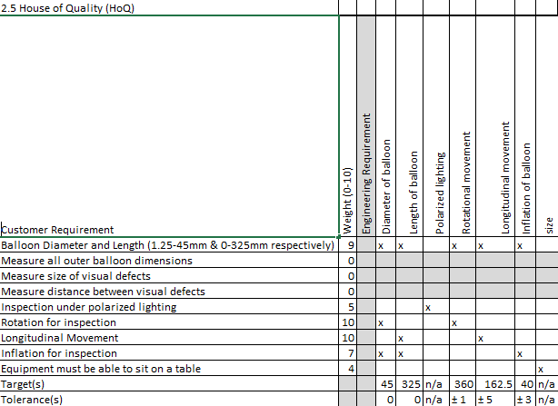

6.2 Appendix B: Drawings
Figure 20 has a lot of moving parts and existing designs incorporated into it. The balloon is attached to a rod which is part of a gear. This gear is a part of the pinion and gear rack design. Instead of making the gear move, the gear rack moves under it to make the balloon rotate while in place. To accomplish this we attach the gear rack onto a modular automation system. The camera is made to only move linearly by the use of a piston linear actuator. With the polarized light not on the camera, it is placed on a metal rod on the other side of the specimen. To ensure the camera and light move together, the bars they are on are connected by metal bars on each side of them.
Pros: stable design
Cons: a lot of moving parts, harder to put together, will cost more, polarized light facing camera lens may make getting pictures difficult
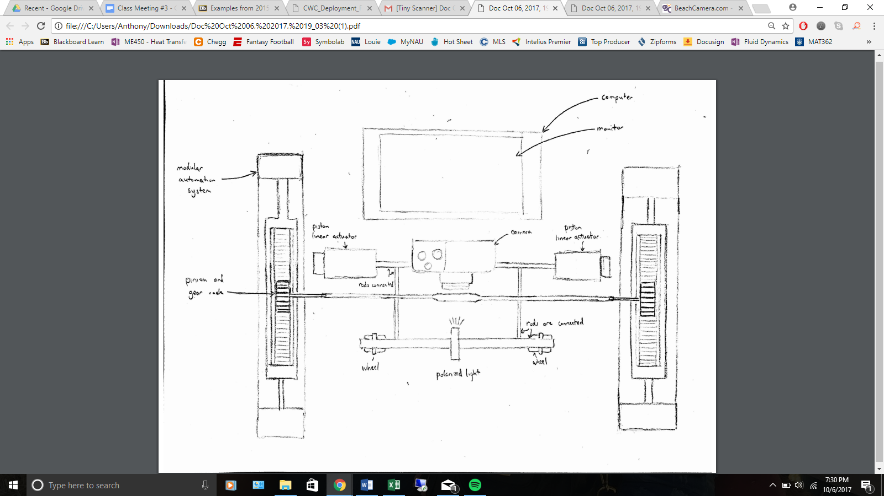
Figure 21: Design #7

Design #8 was meant to be simple with minimal parts.The balloon is attached to a pneumatic rotary actuator to move it rotationally. To make it easy, the camera will move linearly. To do this, the camera is attached to the lateral motion system. Separating the linear and rotational movement to two different parts of the machine. Attached to the camera is piece holding the polarized light directly above the balloon. Doing this makes it so we don’t need another linear motion system for just the polarized light. It will move with the camera.
Pros: simple design, won’t cost that much, polarized light above camera may make it easier to get quality pictures
Cons: may have to create attachment from scratch for polarized light to attach onto camera
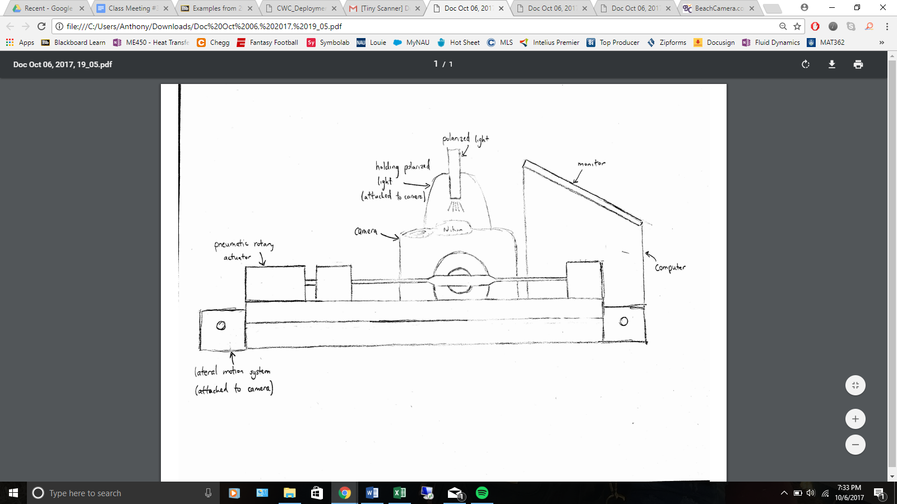
Figure 22: Design #8

Design #9 flips the orientation of the catheter balloon to vertical instead of vertical. The Angular motion comes from rotary motors within the housing. The camera would travel vertically along the dotted line in figure 23 and capture images while the balloon is also rotating.

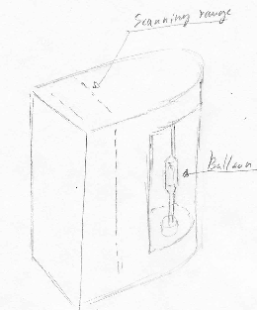
Figure 23: Vertical Scanner

Design #10 is an upgraded version of design #9 in figure 23. This device would include everything from design #9 however this model would also incorporate a display screen. Whether this would pose any advantages is unknown, but the idea behind this design is to be able to use it when and wherever needed.
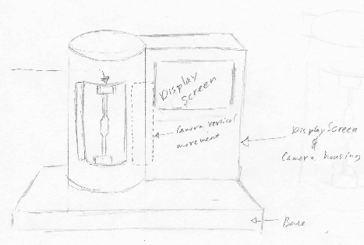
Figure 24: Vertical Scanner With Display

6.3 Appendix C: Bill of Materials
Our budget includes some real totals and some estimates of what we will need to complete the project. This budget is not finished as we will also need to account for manufacturing. Being that we have a budget of up to $20,000, we are only halfway there. This allows us to have plenty of wiggle room to account for manufacturing and any other items that will be added as we progress. This budget does however contain the bulk of the items for the project, with the linear stage, rotary stage, and motion controller being the main components with the highest price.

